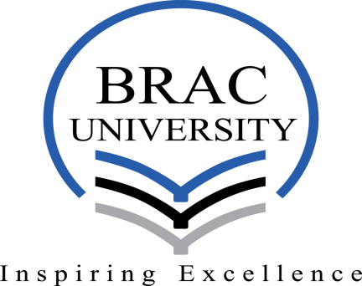

**HUM 101: WORLD CIVILIZATIONS AND CULTURES**

Weekly Worksheet #3 (on Session 7 and 8)

Spring 2022

**Part 1-**

1. **Multiple Choice:**
2. Which of the following can best describe the Axial Age?
3. The battle over ideas producing political and social innovations; (b) Rise of Nomadic Empires; (c) Rise of Zhou Dynasty; (d)New ideas about governance, ethics, and moral conduct; (e) Both a and d.

**ANS:** (e) Both a and d

1. Confucius’s followers transmitted his teachings after his death by the book commonly known as?
2. *Basic Writings of Han Feizi*; (b)*I Ching*; (c)*Tao: The Way*; (d) The *Analects*; (e) *The Book of Lord Shang*

**ANS:** (d) The *Analects*

1. Qin Dynasty forged a centralized Chinese state through which of the following:
2. Relying on the Confucian model of governance; (b)Conquest and Bureaucracy; (c) Ancestor Worshiping; (d) 22 letters without vowels; (e) Applying Daoist teaching.

**ANS:** (b)Conquest and Bureaucracy

1. Which of the following Empress of China challenged Confucian beliefs subordinating women?
2. Empress Wu; (b) Empress Wang Zhengjun; (c)Empress Zhao Feiyan; (d) Empress Fu; (e) None of the above.

**ANS:** (a) Empress Wu

1. **True/False:**
2. The Song Dynasty of China brought about the world’s first industrial revolution: **TRUE**
3. Tang Dynasty of China destroyed over 40,000 Buddhist temples and shrines. **TRUE**
4. **Definitions/Identifications (1 or 2 sentences):**
5. Taoism:

**ANS:** Taoism (also spelled Daoism) is an indigenous religion and philosophy of ancient China.

1. Hundred Masters:

**ANS:** Important part of the Zhou Dynasty for the flourishment of new philosophical ideas. There was hundred schools and masters then and Confucius was one of them.

1. Gun Powder:

**ANS:** Saltpeter mixed with sulfur and charcoal which would burn and could be deployed on the battlefield. Invented by Chinese Alchemists.

**Answer to the question no 5**

“The universalist message of Confucianism enabled Korea and Japan to attack the legitimacy of the Sinocentric world order during the early Qing, on the argument that ‘barbarians’ could not be transformed into ‘Sons of Heaven’” – this quote is explained below:

To begin with, let’s understand what Confucianism is in the first place. Confucianism is a compilation of some virtues and rules, developed by the great Confucius, one of the ‘Hundred Masters’. Values like filial piety, ancestors’ worship, a virtuous life etc are given so much emphasize in Confucianism. Besides, the importance of inner moral harmony and its direct connection with physical world harmony is emphasized. Furthermore, it is said that, the rulers and the teachers are a crucial role models for larger society. With a view to gaining the peoples emotion and esteem, rulers must be benevolent, rather using force. All these virtues along with some more constitute the idea of Confucianism. To get going with the discussion, we need to know about Sinocentric world order as well. Sinocentrism is the belief that world’s cultural, economic and political center is China. The Sinocentric World Order was conceived in China. Because of Confucianism's universalist direction, conquerors who followed its rules were able to gain the Confucian elite's approval, which made them more acceptable and legitimate. We need to know about two more topics. Now, we call ‘barbarians’ those who are perceived uncultured, inferior. And lastly, ‘Sons of Heaven’ is an exact opposite term of barbarians. The sons of heavens are usually monarchs, who has direct connection and communication with God.

Secondly, talking about Sinocentric concept, it was a Chinese project. As it is the belief of being the center, in this case China, they considered themselves the superior. Their claim was further solidified by the sayings in the Mandate of the heaven. China claimed its superiority over Japan and Korea as well, which were their neighboring country. The main motive of China was then to become the continental power and dominate over its neighbors.

Eventually the concept of Confucianism went on spreading and countries like Japan and Korea had also adopted that. As a result, both of the countries claimed that they were the legitimate and rightful ruler and heir of the new civilized world order.

Japan mended some of the teachings of Confucius and incorporated the beliefs of Shinto religion with those. Japan claimed their country as a divine country. However, Korea didn’t accept all the beliefs of Confucianism and adopted some of the beliefs along with their teachings.

As a result, both of the countries dropped the idea of Sinocentric universalism by attacking the legitimacy of such idea. For China, other peoples were barbarians, but now, the barbarians also found out a way to transform into ‘Sons of Heaven’.